PM2.5/10
Sensor
User Manual
JXBS-3001-PM2.5/10
Ver1.1
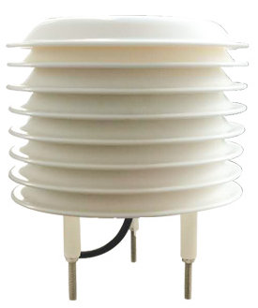
Weihai JXCT Electronic Technology Co., Ltd

Chapter I Product Introduction

General Info
The PM2.5/10 sensor uses a laser probe for professional testing of PM2.5/10 concentration sensors as the core detection device; it has a wide measurement range, high accuracy, good linearity, good versatility, easy use, easy installation, long transmission distance, Moderate price and moderate characteristics.
The system uses a pumping probe, and the air is pumped into the sensor by a fan, which has a better response speed and higher accuracy than ordinary diffusion sensors.

Feature and Function
This product adopts high-sensitivity gas detection probe, with stable signal and high precision. It has the characteristics of wide measurement range, good linearity, convenient use, easy installation, long transmission distance and moderate price.

Main Specs
Item | Specs
Power | 12V-24V DC
Average Current | <85mA
PM2.5/10 Detect Range | 0-300ug/m³
PM2.5/10 Accuracy | <Reading ±10%(25℃)
Stability | <2%F·S
Resolution | 0.1ug/m3
Response Time | ≤15S
Preheat time | 2min; 10min(Max Accuracy)
Output Signal | RS485
Power Consumption | ≤1.2W(@12V DC, 25℃)
Working Air Pressure | 0.9-1.1atm

System Structure
This sensor can be connected and used alone. First, use a 12V DC power supply. The device can be directly connected to a PLC with a 485 interface, and it can be connected to a single-chip microcomputer through a 485 interface chip. The single-chip microcomputer and PLC can be programmed through the modbus protocol specified later to cooperate with the sensor. At the same time, use USB to 485 to connect to the computer, and use the sensor configuration tool provided by our company for configuration and testing.
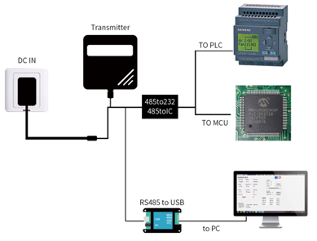
This product can also be used by combining multiple sensors on a single 485 bus. Please follow the "485 bus field wiring rules" (see appendix) when performing 485 bus combination. In theory, one bus can be connected to more than 16 485 sensors. If you need to connect more 485 sensors, you can use a 485 repeater to expand more 485 devices, and the other end is connected to a PLC with a 485 interface through a 485 interface chip. Connect the single-chip microcomputer, or use USB to 485 to connect to the computer, and use the sensor configuration tool provided by our company to configure and test.
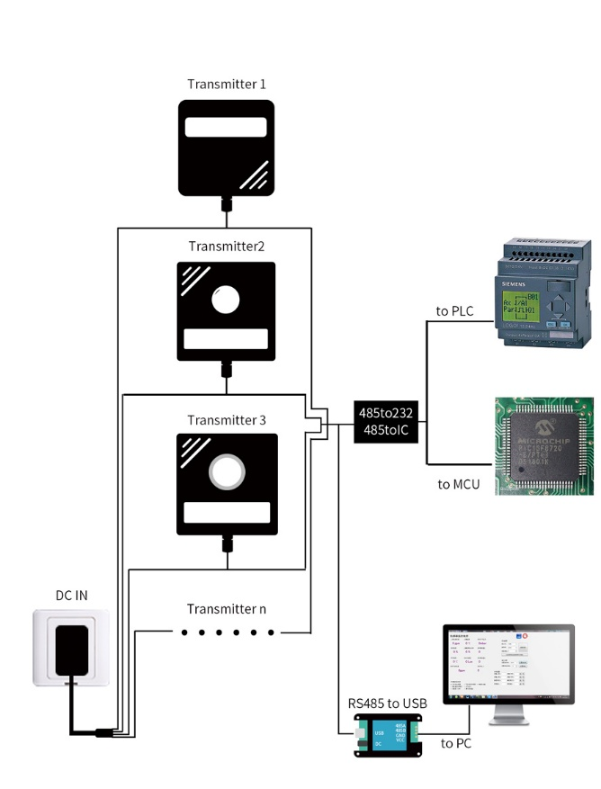

Chapter II Hardware Sensor

2.1 Product Cable Wiring

The power interface is a wide voltage power input of 12-24V. When wiring the 485 signal wire, pay attention to the two wires A/B not reversed, and the addresses of multiple devices on the bus cannot conflict.
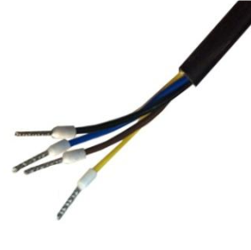

 | Line | Description
Power | Brown | Cathode(12-24VDC)
Power | Black | Negative
Communication | Yellow | 485-A
Communication | Blue | 485-B
Note: Please be careful not to connect the wrong wiring sequence, the wrong wiring will cause the equipment to burn.
The factory default provides 0.5 meters long wire, customers can extend the wire as needed or wire in order.
Note that there is no yellow line in the line sequence that may be provided in some factory batches. At this time, the gray line is equivalent to replace the yellow line.

2.2 Installation
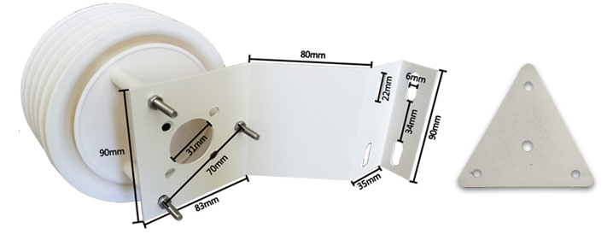
1.Angled Bracket 2. Triangle Bracket

The bottom of the sensor can be installed on a bent board or a triangular board. Install the screws through the holes. If you need to configure, please communicate with the salesperson separately when placing an order.
Chapter III 配置软件安装及使用
Our company provides a complete set of "sensor monitoring software", which can easily use computers to read sensor parameters, while flexibly modifying the device ID and address of the sensor.

3.1 Connect Sensor to Computer
After connecting the sensor to 485 via USB and providing power, you can see the correct COM port in the computer ("My Computer - Attribute - Device Manager - Port").

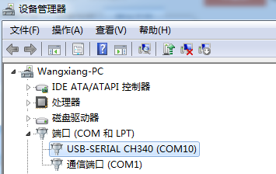
As shown in the figure above, your serial number is COM10 at this time. Please remember this serial number. You need to fill in this serial number in the sensor monitoring software.
If no COM port is found in the device manager, it means that you have not inserted USB to 485 or installed the driver correctly. Please contact the technician for help.

3.2 Application of Sensor Monitoring Software
The configuration interface is shown in the figure. Firstly, the serial number is obtained and the correct serial port is selected according to the method in Chapter 3.1. Then, all devices and baud rates on the current 485 bus can be detected automatically by clicking on the current baud rate and address automatically. Note that there is only one sensor on the 485 bus when using software for automatic acquisition.
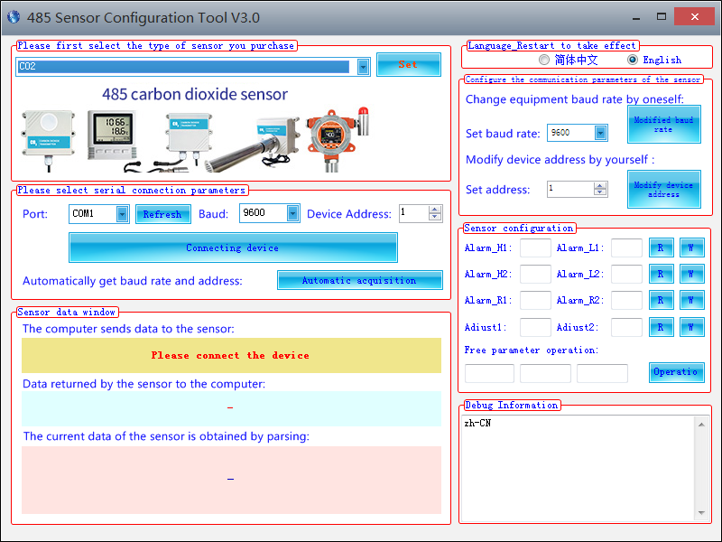

Then the sensor data information can be acquired in real time by clicking on the connection device.
If your equipment is a gas concentration sensor, please select "gas concentration sensor" at the sensor type, formaldehyde sensor choose "formaldehyde transmitter", analog transmitter choose "analog quantity transmitter module", atmospheric pressure sensor choose "atmospheric pressure sensor", and illumination sensor choose "illumination 20". W ", oxygen sensor choose" oxygen transmitter", other sensors choose the default" no other sensor".

3.3 Modify baud rate and device ID
In the case of disconnecting the device, click on the device baud rate and setting address in the communication settings to complete the relevant settings. Please note that after setting, please restart the device, and then "automatically get the current baud rate and address" can find that the address and baud rate have changed to the address and baud rate you need.
If you need to use the Modbus instruction to modify the baud rate and address, you can see the appendix "How to use the Modbus instruction to modify the baud rate and address".

Chapter III Communication Protocol
4.1 Basic Communication Parameters
parameter | content
Code | 8-bit binary
Data bits | 8 place
Parity bit | nothing
Stop bit | 1 place
Error Check | CRC (Redundant Cyclic Code)
baud rate | 2400 bps/4800 bps/9600 BPS can be set, default is 9600 BPS

4.2 Data frame format definition
Modbus-RTU protocol is adopted in the following format:
Initial structure >= 4 bytes of time
Address code = 1 byte
Function code = 1 byte
Data area = N bytes
Error Check = 16 Bit CRC Code
End structure >= 4 bytes of time
Address code: The address of the transmitter is unique in the inquiry network (factory default 0x01).
Function code: The instruction function prompt issued by the host computer, this transmitter only uses function code 0x03 (read register data).
Data area: The data area is the specific call area. Note that the high bytes of 16bits data are in front of each other.
CRC Code: Two-byte Check Code

Question frame
Address Code | Function Code | Register  Start | Register  Length | Check Code  Low Bit | Check Code  High Bit
1byte | 1byte | 2byte | 2byte | 1byte | 1byte

Response frame
Address Code | Function Code | Number of valid bytes Address | Data Zone 1 | Data Zone 1 | Data Zone 1
1byte | 1byte | 1byte | 2byte | 2byte | 2byte

4.3 Register address
Address | PLC Configuration address |  | Contect | Operate
0004H |  | 40005 | PM2.5(1ug/m³) | Read Only
0009H |  | 40010 | PM10(1ug/m³) | Read Only
0100H |  | 40101 | Device Address(0-252) | Read Write
0101H |  | 40102 | Baud Rate (2400/4800/9600) | Read Write

4.4 Communication protocol example and explanation

4.4.1 Read PM2.5 Value of Device Address 0x01:
Query frame
Address Code | Function Code | Start Address | Data Length | Check code Low bit | Check code High Bit
0x01 | 0x03 | 0x00,0x04 | 0x00,0x01 | 0xC5 | 0xCB
Reply Frame (For example: read PPM2.5 data to be 6ug/m³)
Address Code | Function Code | Effective bytes | PM2.5 Value | Check code Low bit | Check code High Bit
0x01 | 0x03 | 0x02 | 0x00 0x06 | 0x38 | 0x46
PM2.5:
0006 H(Hexadecimal)=6=>PM2.5=6ug/m³

4.4.2 Read PM10 Value of Device Address 0x01
Query Frame
Address Code | Function Code | Start Address | Data Length | Check code Low bit | Check code High Bit
0x01 | 0x03 | 0x00,0x09 | 0x00,0x01 | 0x54 | 0x08
Reply Frame( For example, read PM10 value to be 7ug/m³)
Address Code | Function Code | Effective bytes | PM10 Value | Check code Low bit | Check code High Bit
0x01 | 0x03 | 0x02 | 0x00 0x07 | 0xF9 | 0x86
PM10：
0007H(Hexadecimal)=7=>PM10=7ug/m³

4.4.3 Read PM2.5/10 value of device address 0x01
Query Frame
Address Code | Function Code | Start Address | Data Length | Check code Low bit | Check code High Bit
0x01 | 0x03 | 0x00,0x04 | 0x00,0x06 | 0x84 | 0x09
Reply Frame
Address Code | Function Code | Effective bytes | PM2.5 Value | No  use  value | PM10  Value | Check code  Low bit | Check code High Bit
0x01 | 0x03 | 0x0C | 0x00 0x05 | 8 | 0x02 0x05 | 0x42 | 0xBF
PM2.5：
0005 H(Hexadecimal)=5=>PM2.5=5ug/m³
PM10：
0005 H(Hexadecimal)=5=>PM10=5ug/m³

